Whole Farm Appraisal Plans
Since 2017, SAFAG has implemented nearly 700 Natural Flood Management (NFM) measures across the Warwickshire Stour Catchment including feeder watercourses in Oxfordshire and Gloucestershire. These are starting to make a significant difference but there is still plenty of opportunity to do more.
We have therefore teamed up with the Environment Agency and Severn Rivers Trust to develop a new initiative which aims to develop plans which maximise flood alleviation opportunities and environmental and water quality improvement through better management of rainwater run off across whole farms.
These plans involve visits of half a day (sometimes more on a large farm) by a qualified farm land management consultant and the production of a report with recommendations for improvement where possible.
They are undertaken at no cost to the farmer or landowner and there is no liability to accept any of the recommendations. Where recommendations are accepted (in relation to NFM) SAFAG will work with the farmer on developing plans for their installation at no cost to the farmer.
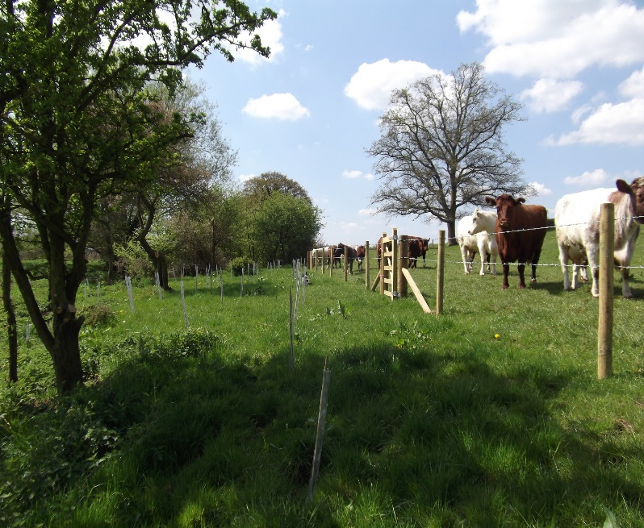
Building on good relationships with farmers and landowners and providing sound advice on water management and soil is seen as key to this and specifically the organic content of soil which is approximately 40% carbon. The higher the organic content of soil the more water can be held within it. If the content is increased by 1% then in just 1 hectare the water retention is increased by 90,000 litres. Clearly on a large scale this provides a very important contribution to Natural Flood management allowing slow release of water to water courses and prevention of run off and diffuse pollution.

Delivery of Whole Farm Plans
We are very aware that the successful relationship we build with farmers and landowners is based upon trust and openness. With this in mind, there will be 1 advisor working within the catchment that can be the single point of contact for the farm advice and whole farm plans.
This work will involve looking at water flow and erosion risk maps for the catchment and identifying the priority holdings to target first which might deliver the best benefits for Natural Flood Management (NFM) measures. Once specific holdings have been identified, the farm advisor would undertake a series of on farm discussions and farm walkovers in order to produce the Whole Farm Plan.

The whole farm plan would include the following:
- Name address and grid reference of the farm/land. Tenant/landlord/etc.
- Farm boundary mapped including any additional land parcels associated with the farm enterprise.
- Visual Silage, Slurry and Agricultural Fuel Oil (SSAFO) inspection. Any breaches to be immediately drawn to landowner’s attention for rectification and will be included in the plan.
- Identify stock access to watercourses.
- Manure and Slurry storage and spreading.
- Farmyard clean and dirty water separation.
- Pesticide stores and handling facilities.
- Soil erosion/surface run off.
- Field drains and ditches.
- Management of fields, including cropping, bare winter soil, livestock grazing times.
- Provision of fertiliser and manure use for fields.
- Any other issues likely to cause pollution or degradation of watercourses.
- Identify interventions to provide NFM benefits. Where interventions are delivered the land manager/farmer/owner will sign an agreement to maintain the structures and interventions installed for a minimum of 5 years. This will be one of the conditions attached to the delivery of interventions.
- Opportunities to benefit biodiversity will be identified.
- The plan will include a table detailing all the natural capital and ecosystem service benefits that the identified interventions could deliver and an approximate cost for each. This would include rainwater harvesting options.
- A map of the holding illustrating the natural capital and ecosystem service benefits identified within the table (see below example).
- Soil compaction testing will be undertaken within a minimum of 3 fields
- Soil pits will be dug in a minimum of 3 fields including a worm count to look at the structure of the soil and look for areas of compaction, depth of compaction, waterlogging which will provide an outline indication of soil health and organic carbon content and water holding capacity within the soil.
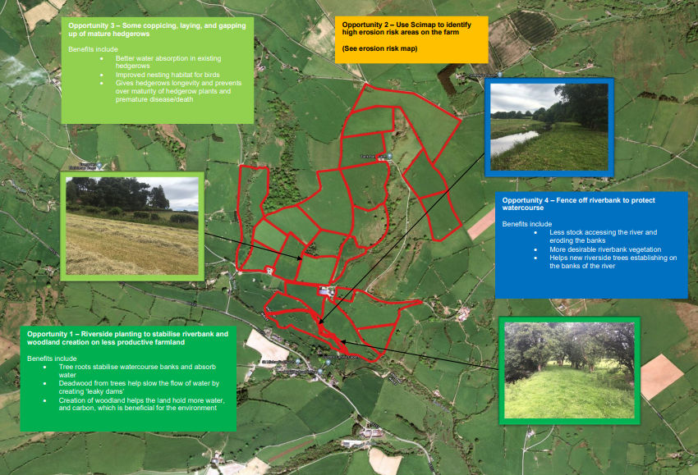

Delivery of NFM Measures
The whole farm plan and discussions with the farmer will identify opportunities to deliver NFM measures on the farm. Where SAFAG has already undertaken works these will be additional and complementary to them. Where compaction issues have been found through the in-field soil pits and advice would include remediation through appropriate soil aeration or sward lifting.

